# **Is a Hotdog a Sandwich?**

Application of Deep Learning and Model Non-Linearity to a Social Dilemma

|  |
| --- |
| Sammy Haq  University of Rochester  500 Joseph C. Wilson Blvd, Rochester, NY 14627  shaq@u.rochester.edu |

**Abstract**

*We attempt to determine whether a hot dog is a sandwich or not by encouraging non-linearity with ELUs and Dropout Regularization as proposed by Srivastava, et. al (2014). Sandwich and food image sets (sandwich-exclusive) are extracted from Stanford’s ImageNet Project and Kaggle datasets, resized, scaled, and normalized before being used to train a convolutional neural network developed by Santana and Hotz (2016). Dropout and ELUs are added to the model in order to add non-linearity. The sandwich-or-not classifier is determined to have 98.52% accuracy at 25 epochs.*

*After model validation, 692 hot dog images are preprocessed similarly and classified using the previously trained classifier. Examination of the results is shown to be inconclusive, with the mean and standard deviation of the results being 50.27% and 43.82%, respectively. Therefore, it is determined that the model is not sufficient enough to determine whether a hot dog is a sandwich or not. We then explore possibilities of improvement of the model.*

# Background

“Is a hotdog a sandwich?” This popular question has been touted by an innumerable amount of individuals worldwide. The American food staple is recognized everywhere as a delicious food that mostly everyone enjoys, but no one quite knows how to classify it. The National Hot Dog and Sausage Council’s President, Janet Riley, once fervently said in an interview that “limiting the hot dog’s significance by saying ‘it’s just a sandwich’ is like calling the Dalai Lama ‘just a guy.’”[1] Others rebuke by pointing to official documents, such as New York State’s Tax Bulletin ST-835 (TB-ST-835), which shows that, for all legal intents and purposes, a hot dog is a sandwich.[2]

Recent popularity of the show *Silicon Valley* on HBO has given much popularity to the usage of hot dogs in deep learning projects due to character Jian-Yang’s *“Not Hotdog”* classifying phone application, which determines whether an object is a hot dog or not a hot dog. As a result, many image datasets exist on the internet that seek to use hot dogs in deep learning applications.

The hotdog-sandwich classification problem has been existent on social media since 2014, and both sides are still split on the topic. In order to bring fresh insight into this dilemma, we explored how convolutional neural networks can be applied to understanding the classification of a hot dog as a sandwich or not a sandwich.

## Methodology

Convolutional Neural Networks are class of deep neural networks well-suited for analyzing visual imagery. Santana and Hotz (2016) used a convolutional neural network in order to create a model for steering a self-driving car.[3] We used the same model from their paper to create a classifier that determines whether a food is a sandwich or not a sandwich (for if a neural network is good enough to steer a car, it is hopefully more than enough to determine whether an object is a sandwich or not). However, we expand on the model by introducing two sources of non-linearity: Exponential Layer Units (ELUs) and dropout regularization.

Exponential Layer Unit (ELU) layers are similar to more well-known activation functions such as Rectified Linear Units (ReLUs) and Leaky ReLUs (LReLUs) in that they benefit from the avoidance of vanishing gradients. However, ELUs have also been shown to benefit from more noise-robustness and better generalization performance for larger layered networks (n > 5). The second method utilized is dropout, a regularization technique proposed by Srivastava, et. Al (2014).[4] Dropout is a technique where neurons are ignored and “dropped-out” randomly during training. This has shown to decrease the reliance of neuron complex co-adaptations, and increasing multiple independent internal representations learned by the network. In other terms, dropout increases the amount of neuron pathways generated during network training towards “correct” result (the network becomes less heavily reliant on critical neurons in the network).

1000 images of items classified as “food” (excluding sandwiches) and 1000 images of sandwiches were taken from the well-reputed ImageNet project and Kaggle respectively, randomly transformed and blurred to increase the number of images per set to 15000, and converted into grayscale in order to reduce the number of features to one-third of their original value – decreasing training time while also decreasing the variance of the images in the process. The images were then normalized in order to reduce variability. Training results are shown in Figure 1. The accuracy and loss of the model is shown to be 98.52% and 0.0456 at 25 epochs, respectively.

After model validation, 692 “hot dog” images were extracted from ImageNet, greyscaled and normalized using the same methodology as for the trained model and fed into the model to classify the hot dog images as “sandwich” or “not a sandwich”.

1. Discussion

The mean and standard deviation of all hot dog images fed into the model are determined to be 0.5 and 0.438, respectively. Because values are only able to be between 0 and 1, this statistically shows that the model is wildly imprecise, with 68% of the reported results being between 0.062 and 0.938. Although Figure 1 may arouse concerns regarding overfitting, an examination of the data in Figure 2 shows that the average remains the same, with the standard deviation minimizing at roughly epoch 5 with a value of 0.1623. Values 0 and 1 represent “not a sandwich” and “sandwich”, respectively. The average being at 0.5 would normally infer that the computer thinks the object is both a hotdog and sandwich. However, the extremely large standard deviation at epoch 20 (approximately 80% of the mean) implies that the model is extremely imprecise. At larger epochs, the standard deviation should decrease due to the overfitting problem and larger biases. Furthermore, Figure 2 also shows that the mean does not drastically change, even when the epochs are updated. This either suggests that the current neural network model is not complex enough for the problem at hand, or not enough data is given. Although the expanded data is sufficient (15000), it is possible that the random affine transformations applied to the raw images were not enough to generate enough discernable data to come to a significant answer.

Another possible shortcoming is the reduction of dimensions and features. All images were reduced to 126 x 126 and greyscaled in order to reduce the amount of variability between images. Doing so may have unabashedly removed features that are crucial to the classification of the inputs.

Neuron dropout also makes weight updating slower when compared to a non-dropout oriented neural network, which might magnify the undecidability of the network when exposed to new data never seen by the model. This reinforces the idea that more raw image data may be required to further facilitate the proper training of the model before applying it to new data. However, with more data it is shown that non-linearity may increase the expressibility of the model enough to more reliably classify a model than a more traditional convolutional neural network.

1. Appendix / Figures

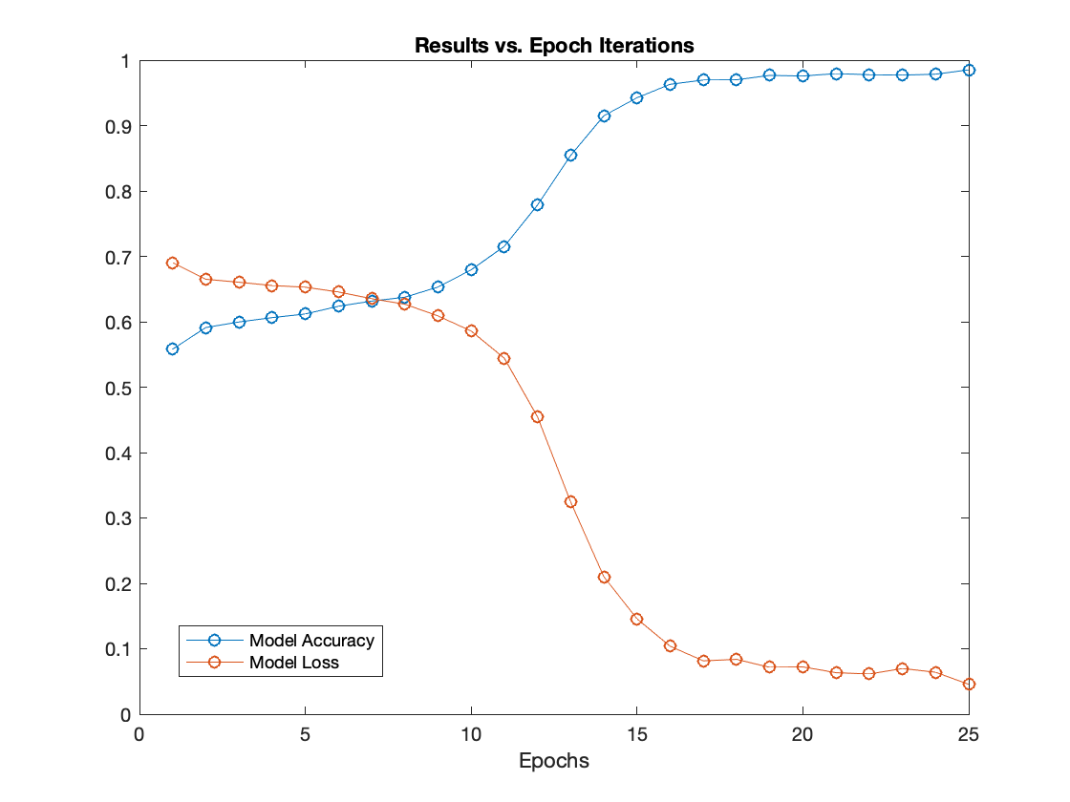

Figure 1. Training results of the initial “sandwich-or-not” model, up to 25 epochs.

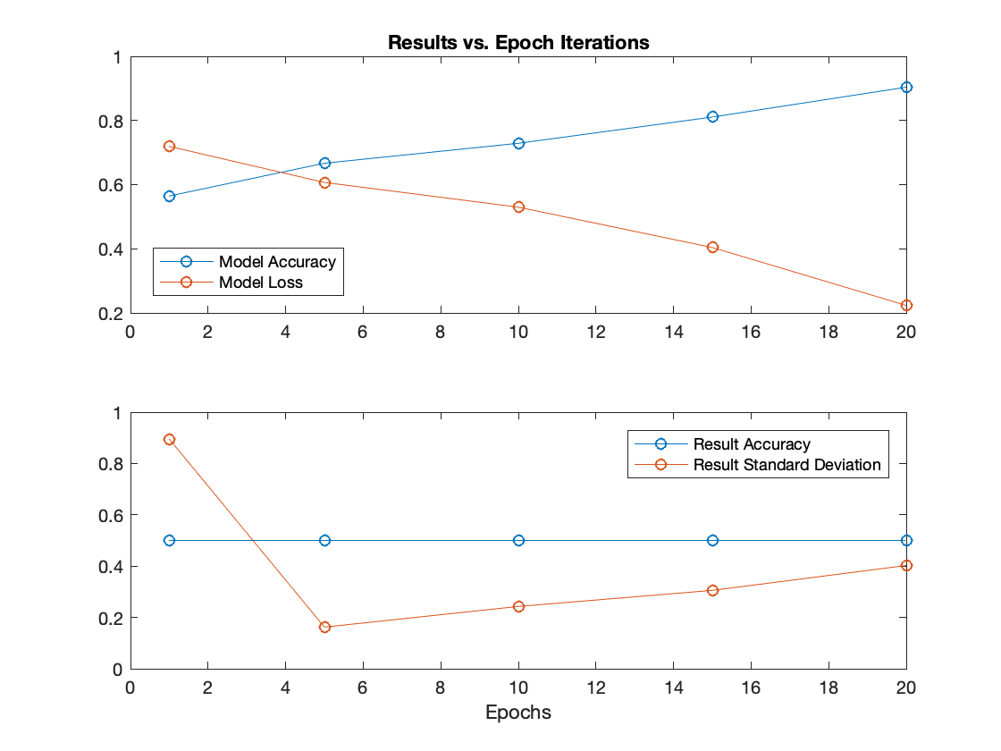

Figure 2. Comparison of “sandwich-or-not” classifier with the performance of the hot dog test results.

1. Deutsch, L. (2015, November 07). Is a hot dog a sandwich? Council rules once and for all.
2. Department of Taxation and Finance. (n.d.). Retrieved from https://www.tax.ny.gov/pubs_and_bulls/tg_bulletins/st/sandwiches.htm
3. Santana, Eder & Hotz, George. (2016). Learning a Driving Simulator.
4. Srivastava, Nitish & Hinton, Geoffrey & Krizhevsky, Alex & Sutskever, Ilya & Salakhutdinov, Ruslan. (2014). Dropout: A Simple Way to Prevent Neural Networks from Overfitting. Journal of Machine Learning Research. 15. 1929-1958.